Jenkins CICI Pipe Line Code for Dictionary App
Step 1) First crate ec2 instance with Ubuntu os and select t2 medium with 16 gb ram and login through moboxterm to that ect and install Jenkins first using below command
#!/bin/bash
sudo apt-get update
sudo apt-get install openjdk-21-jdk -y
#now install jenkins
curl -fsSL https://pkg.jenkins.io/debian-stable/jenkins.io-2023.key | sudo tee /usr/share/keyrings/jenkins-keyring.asc > /dev/null
echo deb [signed-by=/usr/share/keyrings/jenkins-keyring.asc] https://pkg.jenkins.io/debian-stable binary/ | sudo tee /etc/apt/sources.list.d/jenkins.list > /dev/null
sudo apt-get update
sudo apt-get install jenkins -y
sudo systemctl enable jenkins
sudo systemctl start jenkins
sudo systemctl status jenkins

#read jeknins password
sudo cat /var/lib/jenkins/secrets/initialAdminPassword

copy public ip of ec2 and paste on browser with port 8080

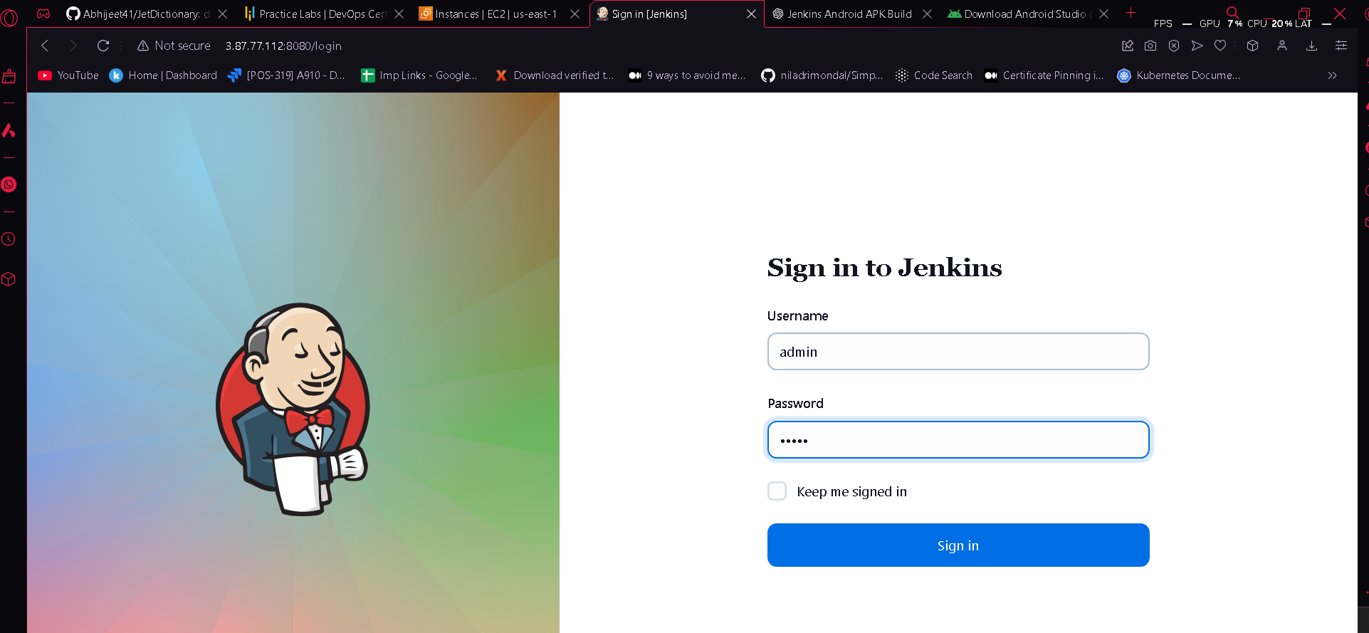
Now got to manage Jenkins and then select tools option and add JDK path
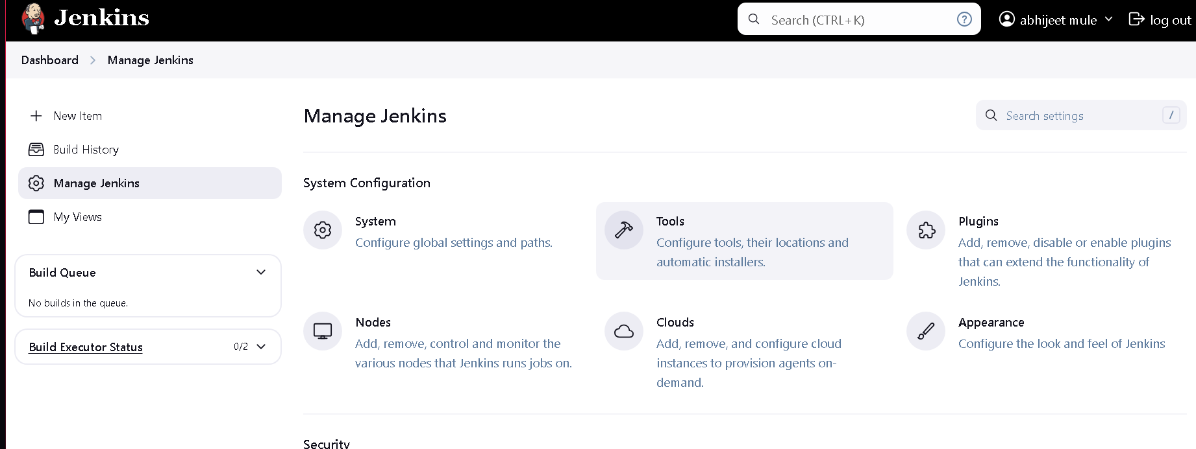
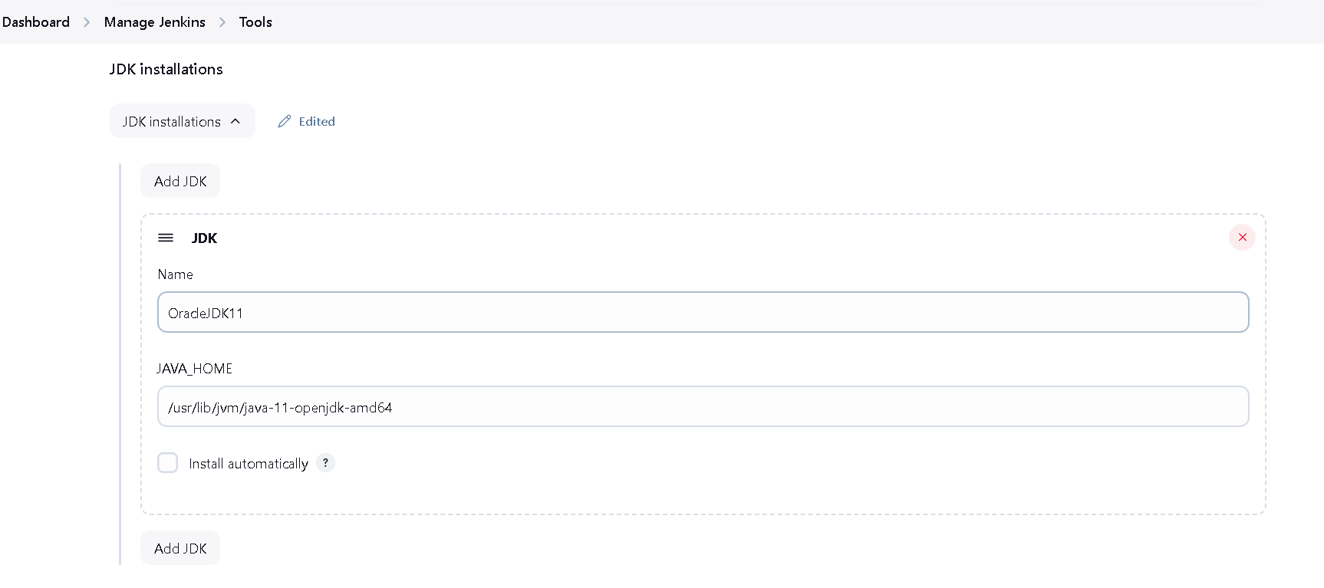
Now go to Manage Jenkins and Select System option in Global properties check Environment variables and add path that we are gonna install in Ubuntu ec2 instance
/home/ubuntu/android-sdk
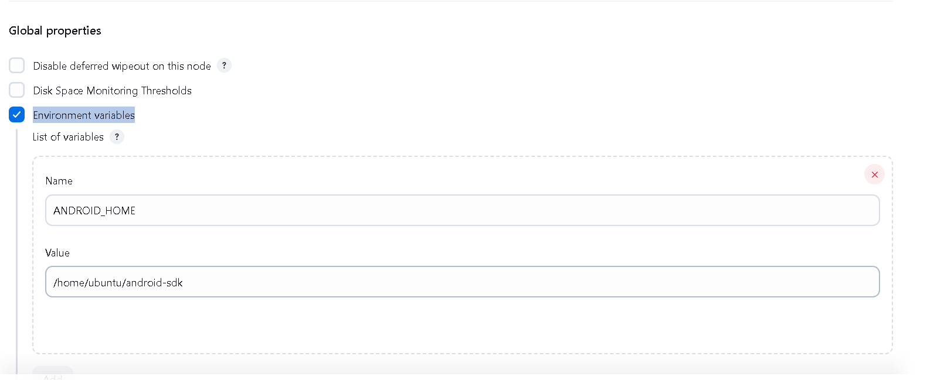

Now use below command to install Command Line tools in Ubuntu Ec2
mkdir -p ~/android-sdk/cmdline-tools
cd ~/android-sdk/cmdline-tools
wget https://dl.google.com/android/repository/commandlinetools-linux-xxxx_latest.zip # replace 'xxxx' with latest version number
unzip commandlinetools-linux-*.zip
mv cmdline-tools latest
Configure ANDROID_HOME and update PATH: Add the following lines to ~/.bashrc to set the environment variables:
export ANDROID_HOME=~/android-sdk
export PATH=$ANDROID_HOME/cmdline-tools/latest/bin:$ANDROID_HOME/platform-tools:$PATH
Apply the changes:
source ~/.bashrc

We used below pipeline script for Dictionary app
pipeline {
agent any
tools {
jdk 'OracleJDK11'
}
stages {
stage('Check ANDROID_HOME') {
steps {
sh 'echo "ANDROID_HOME is set to: $ANDROID_HOME"'
sh 'ls $ANDROID_HOME'
}
}
stage('Set Permissions') {
steps {
sh 'chmod +x ./gradlew'
}
}
stage('Set up SDK path') {
steps {
sh 'echo "sdk.dir=$ANDROID_HOME" > local.properties'
}
}
stage('Clean Gradle') {
steps {
sh './gradlew clean --no-daemon'
}
}

stage('Build') {
steps {
sh './gradlew assembleRelease'
}
}
}
post {
success {
archiveArtifacts artifacts: 'app/build/outputs/apk/release/*.apk', allowEmptyArchive: true
echo 'Build completed successfully!'
}
failure {
echo 'Build failed. Please check the logs for errors.'
}
}

After running pipeline now getting below error that indicates permission denied
echo ANDROID_HOME is set to: /home/ubuntu/android-sdk ANDROID_HOME is set to: /home/ubuntu/android-sdk [Pipeline] sh + ls /home/ubuntu/android-sdk ls: cannot access '/home/ubuntu/android-sdk': Permission denied
The "Permission denied" error indicates that the Jenkins process doesn’t have permission to access the Android SDK directory on the EC2 instance. This is common if Jenkins is running under a different user (e.g., jenkins), while the SDK directory is owned by ubuntu. Here’s how to resolve it:
Log in to Your EC2 Instance:
ssh -i /path/to/your-key.pem ubuntu@your-ec2-instance-ip
Check Ownership and Permissions: Run the following command to check the current permissions on the SDK directory:
ls -ld /home/ubuntu/android-sdk

You’ll likely see something like this:
o/p drwxr-xr-x 3 ubuntu ubuntu 4096 Oct 31 10:00 /home/ubuntu/android-sdk

Step 2: Grant Jenkins Access to the SDK Directory
There are a few ways to give Jenkins access:
- Option 1: Change Ownership (Recommended)
  - Change the owner of the SDK directory to the jenkins user

sudo chown -R jenkins:jenkins /home/ubuntu/android-sdk
Option 2: Add Jenkins to the Ubuntu User Group
- Alternatively, add jenkins to the ubuntu group to give it access:
sudo usermod -aG ubuntu Jenkins

Step 3: Restart Jenkins
After modifying permissions, restart Jenkins to apply any group changes:
sudo systemctl restart Jenkins
history of commands that used
ubuntu@ip-172-31-29-146:~$ history
1 sudo systemctl status jenkins
2 java --version
3 clear
4 curl -fsSL https://pkg.jenkins.io/debian-stable/jenkins.io-2023.key | sudo tee /usr/share/keyrings/jenkins-keyring.asc > /dev/null
5 echo deb [signed-by=/usr/share/keyrings/jenkins-keyring.asc] https://pkg.jenkins.io/debian-stable binary/ | sudo tee /etc/apt/sources.list.d/jenkins.li st > /dev/null
6 sudo apt-get update
7 sudo apt-get install jenkins -y
8 sudo systemctl enable jenkins
9 sudo systemctl start jenkins
10 sudo systemctl status jenkins
11 sudo cat /var/lib/jenkins/secrets/initialAdminPassword
12 sudo apt update
13 sudo apt install openjdk-11-jdk -y
14 sudo update-alternatives --config java
15 clear
16 mkdir -p ~/android-sdk/cmdline-tools
17 cd ~/android-sdk/cmdline-tools
18 wget https://dl.google.com/android/repository/commandlinetools-linux-11076708_latest.zip
19 unzip commandlinetools-linux-*.zip
20 sudp apt install unzip
21 sudo apt install unzip
22 unzip commandlinetools-linux-*.zip
23 mv cmdline-tools latest
24 export ANDROID_HOME=~/android-sdk
25 export PATH=$ANDROID_HOME/cmdline-tools/latest/bin:$ANDROID_HOME/platform-tools:$PATH
26 source ~/.bashrc
27 sdkmanager "platform-tools" "build-tools;33.0.0" "platforms;android-33"
28 sudo update-alternatives --config java
29 sdkmanager "platform-tools" "build-tools;33.0.0" "platforms;android-33"
30 sudo apt install gradle -y
31 ls ~/android-sdk
32 cd ..
33 cd ~/android-sdk
34 cd ..
35 ls
36 echo "ANDROID_HOME is set to: $ANDROID_HOME"
37 ls -ld /home/ubuntu/android-sdk
38 sudo chown -R jenkins:jenkins /home/ubuntu/android-sdk
39 sudo usermod -aG ubuntu jenkins
40 sudo chmod -R 755 /home/ubuntu/android-sdk
41 sudo systemctl restart jenkins
42 history
ubuntu@ip-172-31-29-146:~$
final output

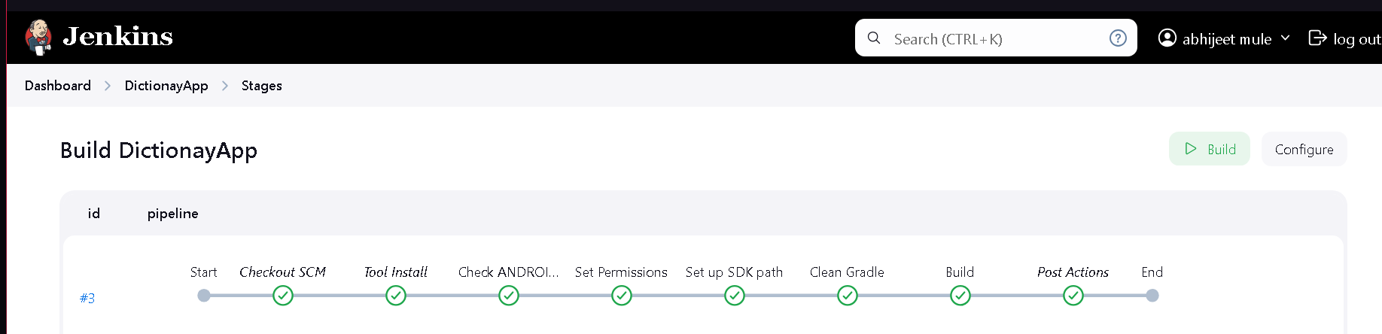

For vagrant setup do same only for path instead of ubuntu set vagrant

The error indicates that certain Android SDK components are missing or their licenses have not been accepted. Follow these steps to resolve the issue:

1. Install Missing SDK Components
You need to install the missing components and accept the licenses.

Install the Required SDK Components
Run the following commands to install the missing packages:
$ sdkmanager "platforms;android-32" "build-tools;30.0.3"

Accept the Licenses
Accept the licenses for the installed components
$ yes | sdkmanager –licenses

2. Verify SDK Components
To verify that the required components are installed, use:
$ sdkmanager –list

The error indicates that certain Android SDK components are missing or their licenses have not been accepted. Follow these steps to resolve the issue:

1. Install Missing SDK Components
You need to install the missing components and accept the licenses.

Install the Required SDK Components
Run the following commands to install the missing packages:
bash
Copy code
sdkmanager "platforms;android-32" "build-tools;30.0.3"

Accept the Licenses
Accept the licenses for the installed components:
bash
Copy code
yes | sdkmanager --licenses
This will ensure all required licenses are accepted.

2. Verify SDK Components
To verify that the required components are installed, use:
bash
Copy code
sdkmanager --list
Ensure you see entries for:
- platforms;android-32
- build-tools;30.0.3

3. Grant Jenkins Access
Ensure the Jenkins user has access to the SDK directory. Run the following commands:
$ sudo chown -R jenkins:jenkins /home/vagrant/Android/Sdk
$ sudo chmod -R 755 /home/vagrant/Android/Sdk

Now Add SonarQube Setup in Dictionary app

Step1) Add Sonar.sh script in vagrant vm or ec2 Instance
Refer below github link
https://github.com/Abhijeet41/vprofile-project-aws/blob/atom/userdata/sonar-setup.sh

you will get this page after paste url with port 80 in browser
http://192.168.56.82:80

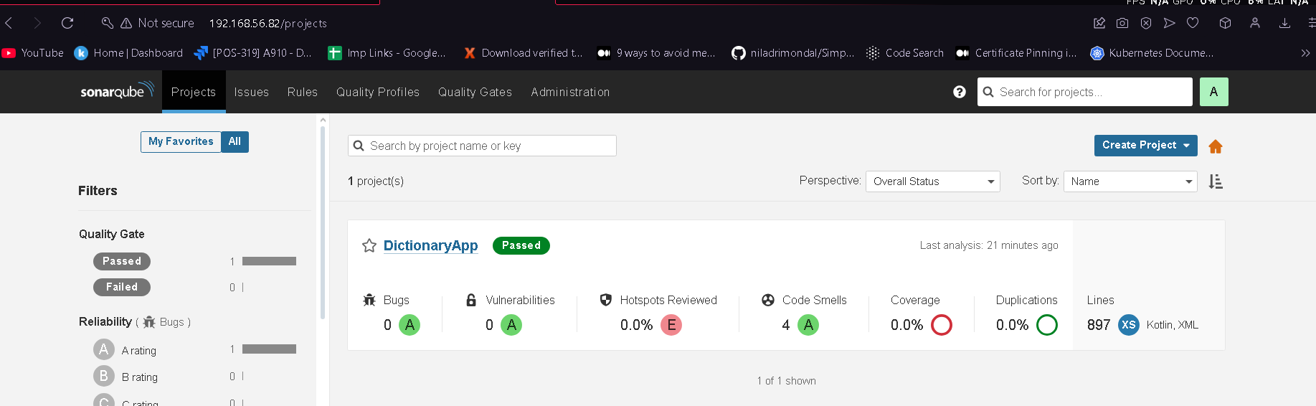
Now click on Administrator and then MyAccount and then select Security tab
And here you should generate the token I set token name Jenkins
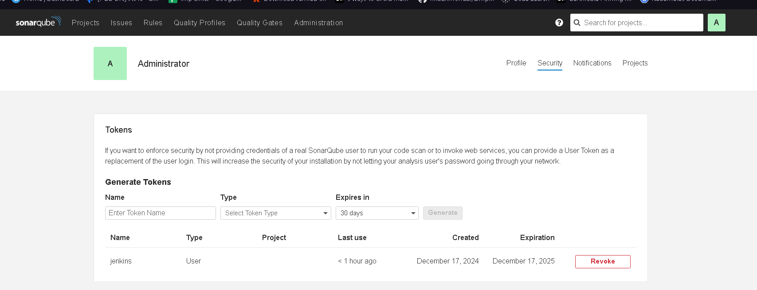
now in Jenkins add below plugins
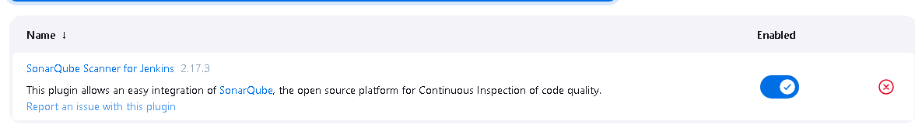
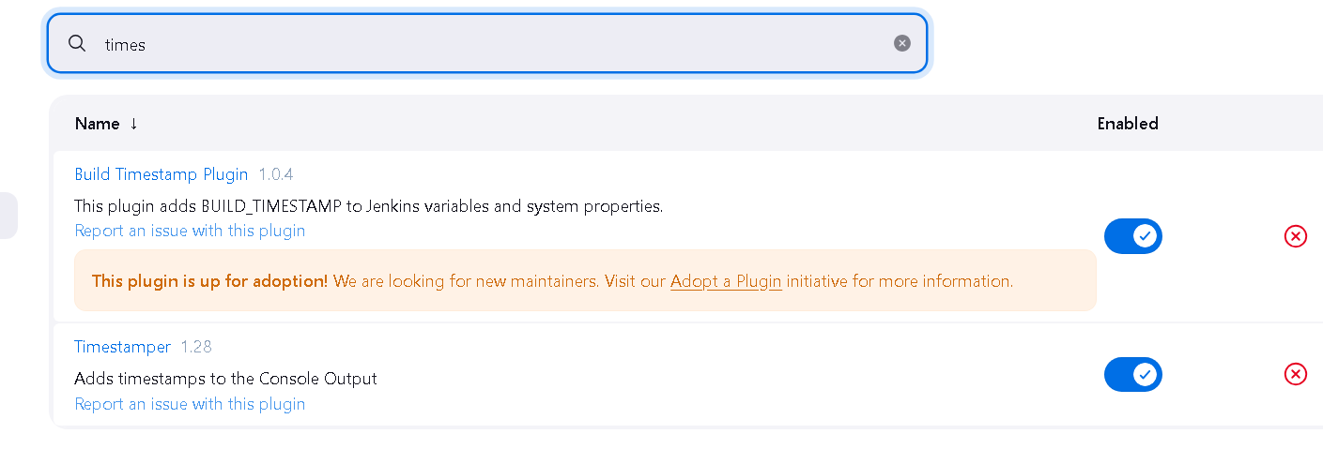
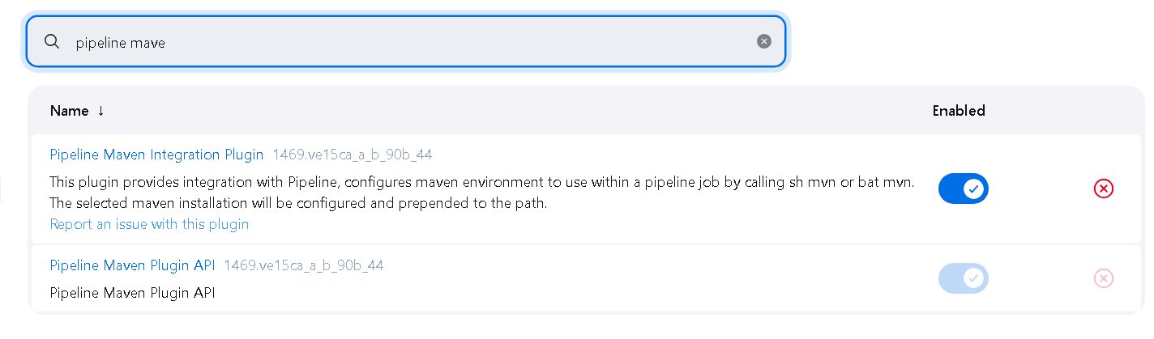
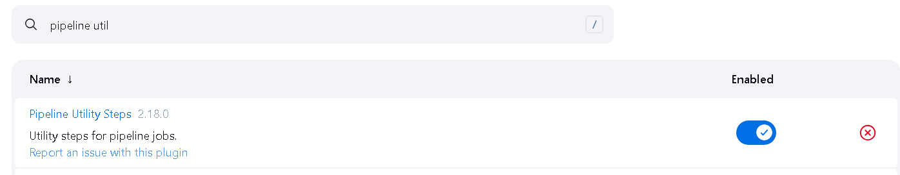

Now Add SonarServer Details in Jenkins

Go to Dashboard > Manage Jenkins -> Tools
Search SonarQube Scanner and click on add sonarqube scanner and set name sonar6.2 and hit apply and save
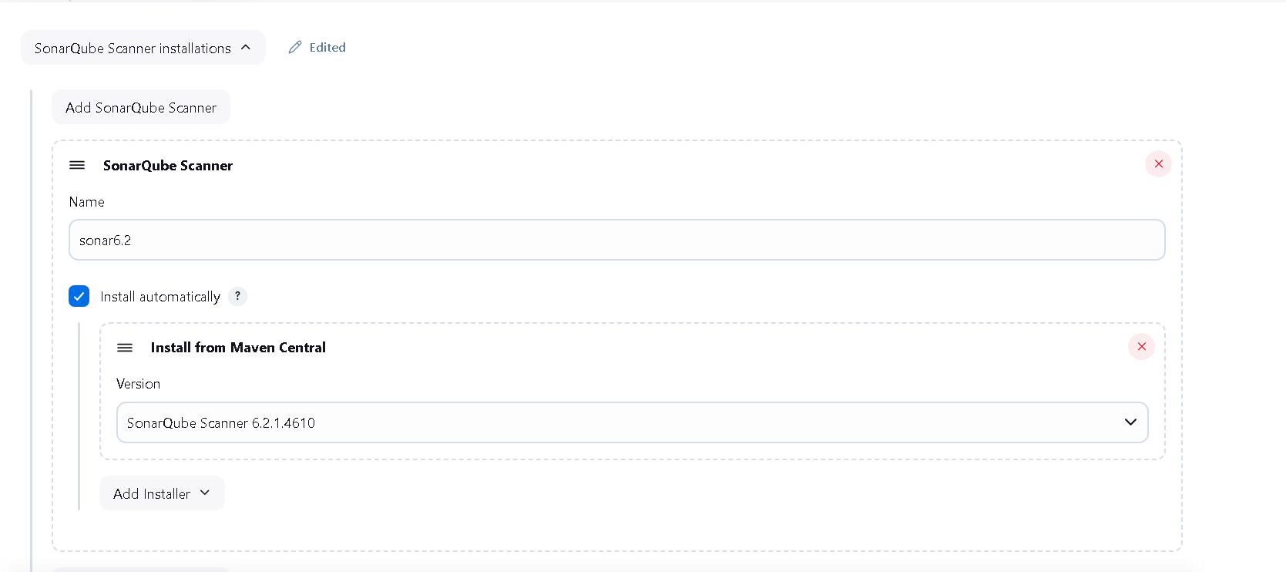

Now for upload result on sonarqube server go to system and set sonar details
System scroll down until see SonarQube servers and check mark Enviroment variables and click on add sonarqube I set my vagrant private ip if you are using ec2 then set ec2 private ip
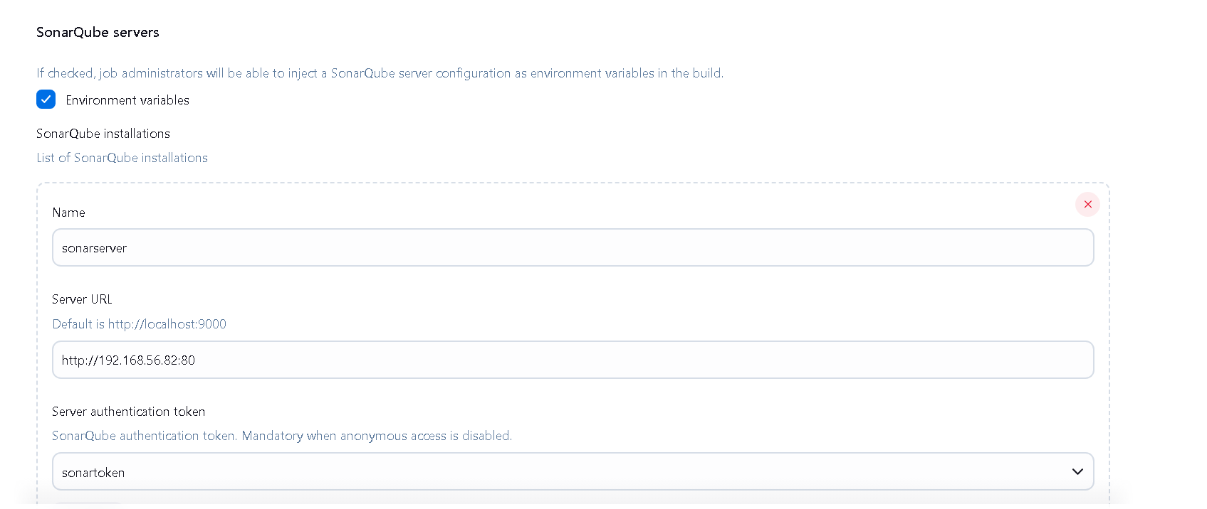
Now here add token that we generate in sonarqube page
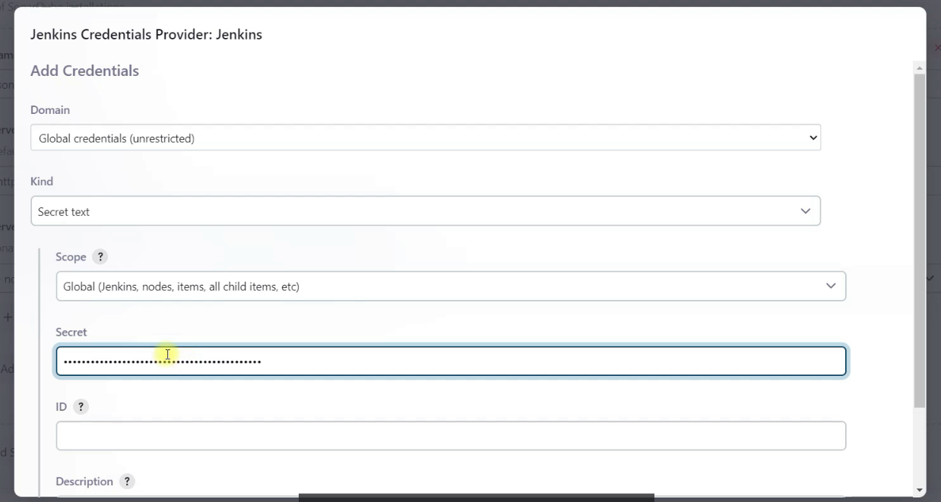
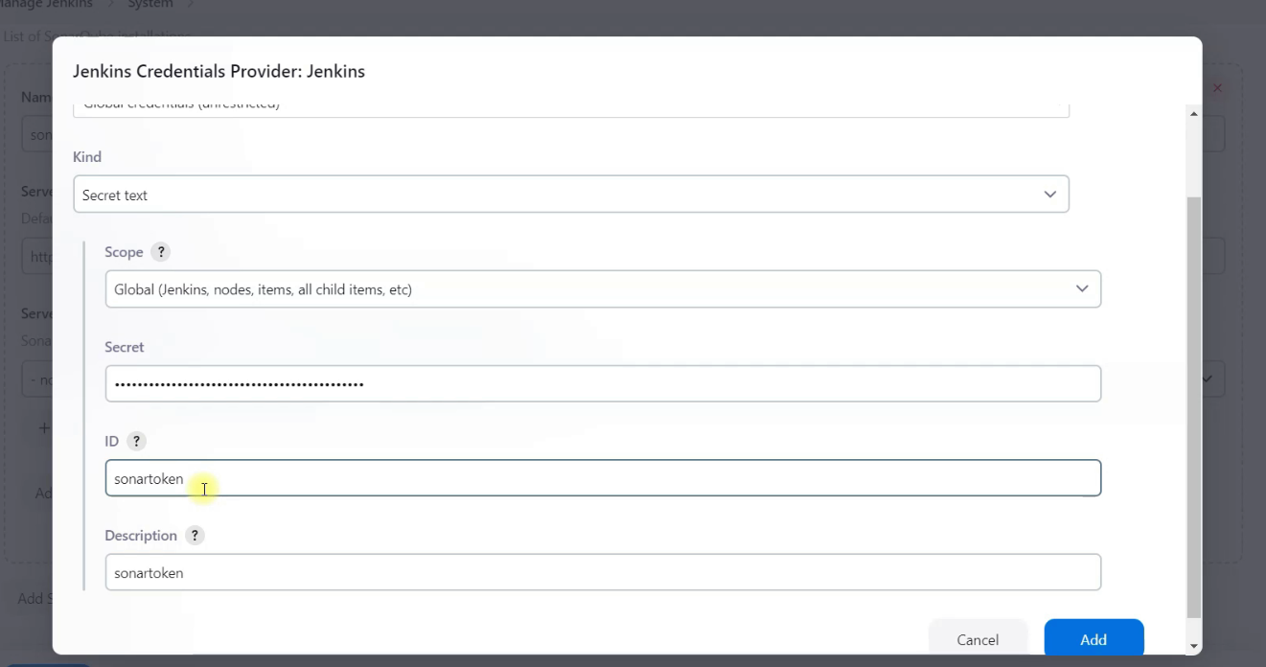

Now Integrate webhook so sonar qube will be send the result using webhook to Jenkins

1) Click on your project name mine is Dictionary App

Now finally in Jenkins file add this below stage

stage('SonarQube Analysis') {
environment {
SONAR_TOKEN = credentials('sonartoken') // Reference the credential ID created in Jenkins
SONARQUBE_URL = 'http://192.168.56.82:9000'
}
steps {
withSonarQubeEnv('sonarserver') { // Replace 'sonarserver' with the name of your SonarQube server in Jenkins
sh '''
sonar-scanner \
-Dsonar.projectKey=DictionaryApp \
-Dsonar.sources=. \
-Dsonar.host.url=$SONARQUBE_URL \
-Dsonar.login=$SONAR_TOKEN'''
}
}
}

Now after adding SonarQube final Jenkinsfile will be

pipeline {
agent any
tools {
jdk 'OracleJDK11'
}
stages {
stage('Check ANDROID_HOME') {
steps {
sh 'echo "ANDROID_HOME is set to: $ANDROID_HOME"'
sh 'ls $ANDROID_HOME'
}
}
stage('Set Permissions') {
steps {
sh 'chmod +x ./gradlew'
}
}
stage('Set up SDK path') {
steps {
sh 'echo "sdk.dir=$ANDROID_HOME" > local.properties'
}
}
stage('Clean Gradle') {
steps {
sh './gradlew clean --no-daemon'
}
}
stage('Build') {
steps {
sh './gradlew assembleRelease'
}
}
stage('SonarQube Analysis') {
environment {
SONAR_TOKEN = credentials('sonartoken') // Reference the credential ID created in Jenkins
SONARQUBE_URL = 'http://192.168.56.82:9000'
}
steps {
withSonarQubeEnv('sonarserver') { // Replace 'sonarserver' with the name of your SonarQube server in Jenkins
sh '''
sonar-scanner \
-Dsonar.projectKey=DictionaryApp \
-Dsonar.sources=. \
-Dsonar.host.url=$SONARQUBE_URL \
-Dsonar.login=$SONAR_TOKEN'''
}
}
}
}
post {
success {
archiveArtifacts artifacts: 'app/build/outputs/apk/release/*.apk', allowEmptyArchive: true
echo 'Build completed successfully!'
}
failure {
echo 'Build failed. Please check the logs for errors.'
}
}
}

